CHAPTER 19

Let's inventory our identity as energy, and begin the construction of images we can share considering what we have covered so far. At the same time, we can get an update as to where we are with our game. No wigging out now! We are in it because this is a game that everyone wins. Game or not, we are now aware that we are energy, our intention here is to be. We vibrate and are able to bring our awareness of vibration into relevance by presence into the (your) experience.

The first game we played allowed us to share information and answer the question; what are we doing here? We are aware that we ARE and that this has relevance, but BEING is our true purpose at this moment especially as we look at the experience around us in present time. We are here NOW to BE. BEING is nothing more than your experience in this moment, that’s it. Simple but oftentimes a challenge to fully embrace, and especially challenging when we are building our awareness into being. Being a presence in the now.

Everyone is having a completely unique experience of their being in the now, and is what makes this presence, your presence, an event. Yes, everyone is having their own experience of this world and the paradigm is your option to embrace. The (your) emergence into the moment as now changes everything, and the energy stream that you identify as you has grown. We welcome our ego (all of them) and unconsciousness as partners into a mass expansion requested by conscious evolution. The Joy is entirely up to you because now you are aware that you “decorate” the experience with feelings, moods, judgements, knowledge, perceptions, connections, control, pleasure, comfort, health and pretty much anything that we get to have as beings expressed through a body. Having-ness has expanded and we no longer equate it with money, possessions or identity. To have is to be. What we are negotiating is decorative to our presence as a neutral expression into the now.

We are still doing, of course, but as we go about our doing we experience BEING. This changes (heals) everything. The tools we use to be are awareness, presence and a consciousness that is able to be present and meet everything as energy within the experience. This at times is playful and surprising and can also be overwhelming because of the intention of focus. The attention to focus is something that the you brings to the experience. All of your energy’s mass is placed through intention, focus and desire to be. Being grounded into a single moment experience is extremely powerful and you bring this awareness to each moment. The now is a wonderland of experience well grounded. We are exploring the expanded options we embrace as sustainability both consciously and unconsciously.

The experience belongs to us and is entirely a construct of our conscious evolution. We have many identities within the experience, some conscious and some unconscious. We are therefore aware that being completely conscious includes an unconsciousness that supports the experience. The unconscious is a relationship that itself is evolving and BEING integrated as an affinitive element to the NOW. So what does that really mean in day to day languaging? As you go about your day and consciously embrace and meet the now, take notice when an unconscious reaction or energy pattern is emerging into your now. Use the moment to not reject the unconsciousness but rather realize it into your moment and upgrade that energy into an energy that supports your experience, not defines it. Yes! Indeed this takes some practice, but once you are a presence in the now you will notice that unconsciousness is interference to you fully embracing the now. Unconsciousness can be like a knee jerk reaction that you consciously embrace, and start to reference that in this way in the now. This allows for the motion and lift of momentum using the current moment to flow into the next moment. Vulnerable for sure, and deeply honest. It is from this place that we can observe the continuance of momentum without judgement about how to fill space-time with our unconscious past time energy as experience. You will never be unconscious in this way again because, once learned, the upgrade of unconscious sustainable energy is broadcast throughout the energy stream that is (you) the experience, and it now is a part of the whole of your conscious energy system. It is still unconscious, but fully backing you up, your egoic mind will adjust also, it too is learning to support you.

This event can show up in your experience something like this: You are driving along when someone suddenly cuts you off and you have to slam on your breaks to avoid an accident, and other drivers are honking their horns giving offensive hand gestures and yelling. Your immediate (reaction) is anger, but it is really fear and you need to stop and pull over in order to just calm down. You breath and you see the other drivers shouting and putting down their windows trying to engage you in an energy match and to see if you are alright. This is a perfect example of all energy coming at you, or so it seems, at once. The truth is you just had an experience where other people were involved in the event and there is tons of energy in the experience you are having right now in this moment. It is an experience composed of energy in the form of mad/angry, scared, horns honking, gestures, yelling and you driving. There is only the now, the experience just described is in past time. YOU HAD AN EXPERIENCE! Yes, you had an experience, and the experience had many components.

It is opportunities like this that pop up each moment and the ability to BE present with everything always is the joy of conscious evolution. How you meet that moment is the experience that is streamed into being as you, and your ability to meet the experience is what makes the joy of conscious evolution such a thrilling adventure. How you choose to behave in the example above is the entire point to choice and our ability to be. It only matters to you. The presence you offer to the experience makes it matter by you streaming energy to it by choice. In other words, you make it matter with the choices you make and the choices you do not make.

We are going to look at the legs and feet again, but this time with the expanded awareness that we have choice and we also do not have choice depending entirely upon our relationship with ourselves, the conscious and unconscious, and the programing we encounter. When the being that is you establishes a presence in the now, the ability to recognize programing either through your lineage or just the day-to-day mental construct invested into unconsciousness, you begin a conscious evolution that is a revolution to the (your) experience, and there is no going back.
The legs and feet are like the hands and arms fundamental to our direction and ability to walk the talk and be a presence in present time. Our legs are where almost all of the programing is stored about your true identity. Our legs tell us how we are all unconsciously controlled, mentally enslaved, who you really are, what you come from, and the energy stream that is a sustainable natural resource, and the most precious energy.

As we previously saw in our exploration of the arms and hands; why we are here is to access sustainable energy, and to experience the joy of conscious evolution. The experience is our source of energy as expressed through our bodies. The knowledge that we are here to access sustainable energy is not apparent to everyone automatically. The ability to recognize this within ourselves is contained within the momentum of our energy field. You either are interested in yourself in this particular way or perhaps you are not. Nevertheless, resistance is feudal. It is feudal because conscious evolution has learned the lessons of BEING SEPARATED and WHOLENESS is what consciousness is requiring within the experience in most of the people I witness in readings. Conscious evolution will provide you with an option, but only if you are willing (fifth chakra) to consider the present moment.

Clairvoyantly, this looks oftentimes as if the legs can ground in present time, and at the same moment extend into the resource of sustainable energy. Thereby debriefing the programming deeply held in the legs by literally walking the being (you) into an emergence of the NOW that is the journey. This journey is a change in direction and purpose vividly apparent in the experience you are having in present time. You may, quit your job, move, break up with your partner, start a new relationship, look at money differently, go someplace you have never been before or change your life completely. Especially around how you feel about your life purpose, let go of material things and bring new people into your life. The pictures that show up are pictures of things you have never done beforeand do not know how to do, but are willing to learn even if it means drastic changes to our overall identity,

Why now? This may be a game changer for some of us. Why be here now? Will I have to stop shopping and enjoying TV? Will my life be all serious and no fun? Well, the prospect of discovering that you are controlled by programing that you are slowly becoming aware of, that television may not be as entertaining as it once was, and that shopping can distract you from the presence of your conscious intentions might influence these choices. That is entirely up to you, and of course, the experience you are having in present time. We are conscious that multiple experiences are contained within the experience we generate through our presence. Coming to terms with what is unconscious and ego driven is apparent in our experience, and once we glimpse from the conscious presence that is now we have stepped through the looking glass and a whole new world explodes into our consciousness.

Multiple experiences contained within your experience could look like: I’m answering a lot of backed up emails, cooking dinner, worried about a friend, distracted by the leaf blower going off next door, hot because the air conditioner is broken, feeling angry and tired, nothing good on TV . . Or multiple experiences contained within the experience could look like: I’m aware that I am here now, a past time and unconscious energy pattern is surfacing in the form of fear of intimacy, I am drinking too much coffee to give me energy, I’m aware that my presence is apparent, I see into everything, I can see beyond my vision of sight, when I close my eyes I see images, water translates to me as my own emotional excitement and joy, I know I can meet my moment, I appreciate all the people who support me, I set the table for dinner and did it well, I had fun making a beautiful flower arrangement.

All of these particulars are of no consequence except to me or you and the ability to meet the experience. I used purposely simple and ordinary examples here because most of the time it is just like this, a collection of “doings” occurring as the experience in the moment.

It is in these mundane examples that we start to look for our physical and energetic legs to take us into a multidimensional experience that has motion, lift, and a momentum that allows us to make choices or to not make choices and emerge into our evolutionary destiny or journey.
Nothing is mundane or ordinary in an experience if the consciousness having the experience is aware that a stored in the legs is a program that exists and could unconsciously engaged, and override the conscious ability to be present.

Unconsciousness as a past time energy pattern does not allow ME to be present, or perhaps my mentalness creates a separation that dominates my experience. I can also egotistically project my energy onto the other people in the experience I am having and make me right. The only way out is through, and the legs hold the literal motion to walk us out of this energy configuration. This is also an energy reconfiguration for people who do not have physical legs, are in a wheelchair, walker, etc.

The ability to have many windows open within your reality frame in the NOW is where it gets very interesting. It’s just like your computer where you can have many pages open and be looking at them at the same time or not. The need of what to DO in your moment is revealed only in the NOW. You have to BE in the now to meet the experience, and be prepared for what that looks like as the experience. Remember, you are constantly changing. This change is the momentum of your energy as you move through space in the absolute stillness of form. This is why energy is readable. It is exactly like looking at a snapshot of the space where you reveal your form. Your form shows up as pictures or energy images where you have collapsed a wave pattern and made something matter by placing your attention on it for whatever the reason. We come to understand that this reason is a choice and choice is the picture I look at in clairvoyant readings.

I have no idea what your experience is for you. I would be able to give you a very clear understanding of what your experience is like if we were doing a clairvoyant reading. However, your experience is your experience. No two people are having even a remotely similar experience despite what you might think or feel. We share our experience to feel whole and to avoid the separations that compose the elemental structure of our experiences. We are now in the process of relationship where we advance to wholeness, this will shift your paradigm. This can look like you are simply making the effort to be.

By all means shop and watch TV as much as you like, but understand exactly what you are exchanging your energy for and how much of your experience is conscious. We have constructed a paradigm where our energy is bought and sold like pork belly’s on the stock market. The stock market like most things we do in life is a distiller of energy, we all feed our energy stream into the things we do in an exchange, and for most of us we get nothing in return. It is a lot like the using gasoline example or a bank loan just placing your thought energy on it makes it matter, and you exchange energy.

Remember we are establishing a sustainable energy presence. Any unconscious past time energy patterns that separate you from sustainability is not in your best interest as a consciously evolving being. We are making the effort to be aware of our unconscious so we can establish our backup of support. The unconscious reaction is not a part of the present now, and we are in the process of learning how to override the autopilot drive that distracts our conscious awareness.

This is easily made apparent, but what about the seemly passive giving of our energy through just thinking about anything? We exist at a time when this lack of presence within the experience is a lot like tossing one hundred dollar bills into the air, lots of them, and watching people scramble to pick up your toss of money. Symbolic of so many choices we make each and every moment. Consider the bills individual thought energy, each note is a choice the value of which is prized by everyone scrambling to get your energy, and of choice you so freely give. This is the experience we see constantly as choices often not made. By not making the choice you have made a choice and allowed access to your dimension of sustainable energy. In other words, you are giving your energy away unconsciously, seemly willingly!

This can also look like thinking about politics, worrying about the election and voting as if the choice mattered. It matters to you, or it does not matter to you. They both energetically matter exactly as the same thing, and the industry scrambles to collect your support freely given. You believe you are giving your support. However, the whole industry of government is invested deeply in the unconscious experience. It is an important part of the experience to project a reassurance of security and safety grounded in fear. Just like the people scrambling for the hundred dollar bills we all scramble with a rational national investment in fear and global lack of awareness in your ability to be here now, and this is experienced unconsciously.
We cannot make a choice if we are not aware of what choice we have to make. Yet by not making a choice, and especially by not making a choice, you give access to your energy be it money or votes, with a lack of awareness. Getting your presence out of the way is what unconsciousness and egoic mind do. So why here and why now? Because some crazy guy just tossed one hundred dollar bills in the air or some guy did not vote in the election. How can these seemly unrelated events matter to the experience? It only matters to the experience you are having but we think it matters to all of our experiences because we are programed that way, and the programs sole interest is acquiring your energy, all of it, always.

Let’s get back to our game and see if we can find some answers to these questions. To enhance our game of finding out why now, let’s add to our questions. Let's ask what a sustainable source of energy feels like? How do I even think, let alone feel into such a resource? If everyone is so hell bent on getting my energy, grabbing for it, soliciting for it, how does my being present matter?

As you experienced in the extended arms exercise we can touch our energy field by reaching into it consciously. Together we are building an energy conscious identity, so any doubt or uncertainty while anticipated is an unconscious past time energy pattern that keeps you in a three-dimensional containment.

This is our joy of conscious evolution. Together by walking into the experience that is the now. We offer ourselves and anyone else who shows up in the (our) experience our expanded presence in the now and that is a different experience for each of us and “why now” of our game. Because only now can we be. You might want to say, so what? What is the big deal? So I can be present in the now, I still have to go to work, buy gasoline, watch crappy TV shows, get sick, and die!

Yes, this means you may discover bumps in the road as you journey into conscious evolution. Some of the bumps were there before you considered consciousness and unconsciously they felt no different than they do now!

Keep in mind that you are in unexplored space time and it is natural to feel confused or uncertain about your experience. If you are completely thrilled with your experience then it can only get better. Three-dimensional reality is a dualistic experience, never based in present time. It has nothing whatsoever to do with present time or an experience based as BEING. As we expand our presence in the now we bring the grace to the experience and appreciate it by just being able to meet the now. So just by you as an experience meeting the present moment you consciously alter three- dimensional space-time. It all looks the same to me, what is altered?

Busting free of compromising and energy draining situations within our experience is liberating and scary at the same time. Declaring your independence from containment and perhaps contentment with what you THOUGHT was ‘the good life” is possible once you get out of your head and into all of the space you exist from. The head is letting go of the control it believed it needed to survive, and the story it has been telling you most of your life. This changes your experience in a big way, and you cannot BE subjugated to egoic mind. This letting go is startling and definitely takes a lot of getting used to as an experience. I see people bouncing from their mind to their essence as now with the actual moment to moment experience. This “looks” natural as an equilibrium is established.

A lot of anger is felt and brought into the experience as you consciously evolve mostly because you have given up so much for so little in return. Understanding that this anger is also a construct of the three-dimensional prison designed to keep you forking over your energy. Countless amounts of people have no consciousness apparent to what is My energy versus what is energy?

As we saw in the energy centers of arms and hands you have to get used to imagining yourself outside of containment. Using your mind, feelings, will, vision, affinity, control, and abilities to manipulate energy, and manifest change, all combined, is how you approach the question of, why now? Let me give you a hint, it’s not to throw one hundred dollar bills in the air or vote or not vote in the next election.

It is with our extremities that we have tools to manipulate energy organically and naturally Let’s take a look at the legs and feet again, and see what else we have to play with as we go about our game of exploring ourselves as energy. This time we will consider our sustainable energy and why it is so valuable to our journey, and why others want to capture it so eagerly. The energy centers of the feet make contact to the planet Earth. The feet attach to the legs and act as a tuning fork signaling a frequency valence to the planet, the solar system, the galaxy and ultimately, the universe. This ability is strongest in the legs and feet.

We commonly call these abilities grounding. The feet, legs and sacrum are the places that you can create any type of grounding technique that suits you. The base of the spine, legs and feet all function as a connective link into this planet. Body-being-space-time is a conscious experience, however unconscious relationships systems are often in place of consciousness.
Grounding, manifesting and Earth are all energies within the experience. The experience right now involves a body, and we need the body to be present with us so we can consciously evolve from this presence.

The easiest way to lose energy or give up your energy is to be ungrounded. The same programing that makes any of us an energy slave has a huge vested interest in keeping people ungrounded. The ungrounded person is wide open for manipulation and programing. Television is an excellent way to be programed, especially while sedated (alcohol, drugs).
Children are especially prone to programing. They are rarely in their bodies and often rely upon the adult to allow them to ground through them. This an important service a parent provides to their children. Often children are completely ungrounded all of their youth, teens and early adulthood. During this time period programing is accomplished.

Each foot and leg act differently in just how we go about experiencing that connection and relationship. Our bodies and the Earth are in a relationship with time so that we are beings acting through a body on Earth for however long. The left leg and foot are energetically very different than our right leg and foot. Both feet provide a connection to Earth, but each do it in unique ways for us. The left leg has full access to the dimension of sustainable energy on our left side and at the same time be grounded in present time. The left foot and leg can explore all probability of events, states of matter, choices we did not make, and all of these can be available to us if we as knowingness (seventh chakra) meet our presence as experience. This is just saying grounded into the now of present time as an energy field. The probability of anything is resting in a potential state always. Being able to bring this awareness into the presence of now is, in our experience, all about where you place that left foot and the radiance of intention as vibration and pitch. Discordance shows up in a reading as issues, and the pictures are usually about money, success, where to live, anger, pissed off, hip or knee replacement, uncertainty, seeking, and as you can see, a variety of “reasons.” It really depends completely on the person, the life circumstance, and of course, the programing that went into the culmination of this particular life event.

Fundamental to the left leg is that it has access to the dimension on the left where the potential event or possible outcome is at rest until witnessed and in a sense activated by you paying attention to it, or not. Either way the dimension on the left is full of energy and if you don’t use it someone or something else will either by taking it from you or you giving it away unconsciously. We are all programed from birth to give up vast sums of or energy.

Like the arms and hands, the legs and feet access the spacial dimensions to our left and right similarly. The legs and feet provide additional abilities for our expanded energy field. The left leg is directed to the future space-time and develops a path or purpose for having that connection. The left leg can take us to where we desire to go but it also may not understand where we want to go, especially if we are not present with all the choices available to us. This is where programing has narrowed our choices for us and we accept the version of our life we BELIEVE we live. The sixth chakra is so very strongly tied into the chakras of the legs that it is difficult to articulate the tie-in that our thinking patterns, belief system, and values have woven into the actual momentum of our stride, as well as governing the choices we do and do not make. Very often the choices we make are not in our best interest at all as consciously expressed being, but rather a negotiated outcome made for us and mindful (mind-filled) to the depletion of our natural sustainable resource of energy.

Your life experience from the perspective of the left leg is in the form of incoming future time possibilities. In a clairvoyant reading, probable outcome is a speculative future time choice but only if viewed when time is believed to move as an arrow, one direction. Probability is a vast resource or so it seems in a reading. You have choices as to where to place that left foot down, and draw energy up into the body from the dimension below the feet, Earth, as well as the dimension on your left. The only thing that limits your choices is your relationship to the experience you are having in present time. Choosing out of a past time unconscious fear based consideration will obviously not connect you into the present moment, and you will make a choice from a limited perspective (sixth chakra) about where to put your left foot!

Belief patterns are a sixth chakra experience. It is belief patterns the made the people scramble for the one hundred dollar bills thrown into the air, as well as investment into political ideologies. This is all energy and your energy streamed into the experience. When it come to the legs, the ownership of energy as yours becomes relevant because of the body and because of the journey you embark upon as an energy system, and as we shall come to be, the embrace. The now is where our presence take us and this is process of relationship.

The chakra of the left foot considers places, events and situations as possibilities; these possibilities show up as data and information about where and how you want to ground or connect with the planet. We recognize this through things, places or events, and are affected by nature, home or like energy. The left foot and leg are filled with pictures of your experience. This is just one way to consider the left leg especially when grounding into the now. The leg grounded into the now also extends at the same moment into the dimension on or left. This considers choices we did not make, but may reconsider as soon as we expand into the experience. A choice not chosen in the past may have been under the influence of unconsciousness or pre-programed-belief-possibility that selects a choice for us. We did not make a different choice because we were unaware the choice even existed.

The legs in general are very earthy and usually the pictures held in the legs are about the things we energize in the experience like money, career, education, nature and location. The left foot chakra does the connecting by estimating how or where we want to connect. The possibilities are seemly endless and it often “looks” that way. The ankle plays into the choice, but uncertainty will limit the options quickly and what looks like endless choices before now has been narrowed down considerably. The left foot pulls energy from the earth into your body. This is where a lot of our sustainable energy gets taken from us especially when we choose options that right off the top ask you to compromise your choices. This deal is cut, often times for you by the demands of linage, contracts, loans, and primarily belief systems. The pictures or energy images held in the legs tell the story of your intentions. A lack of intention can look like a person you pass on the street, a lost soul, people who just have no “idea” of what they are doing or where they are going. Angry people may have compromised their intention in exchange for something or settled for less. Often the pictures held in the legs vividly distract the person from making contact with the earth and the body suffers ungroundedness. Long term ungroundedness will start to show up as physical or health issues.

The left calf embraces the choice, while the knee provides understanding about the considerations, and the thigh stores all memories of emotional relevance to where we desire to be and go in life. Both legs are very complex energy structures. The legs are what lead us physically into everything we “think” or feel about conscious and unconscious experience. Any compromise to our ability to restore our energy from within our own presence is played out in the way we walk or don’t walk.

All of this is structured through our awareness of having a body and the momentum of movement. We place our left foot into the space and energy of the future or where we want to go and draw energy into our lives by determining what is familiar to us up to that point in time.
The left foot points us in the direction we go.

Possibility is what we are expanding into. As we expand so do the possibilities. Conscious present time awareness of possibilities is like a shopping experience where you can shop in any store and not be limited by a budget or proximity. Being able to take full advantage of this experience is being aware of the opportunity. The only limiting factors are the energy images we hold in our legs that dictate a limited amount of anything be it money, privilege, security, beliefs, feelings, etc.

Energy can be limited by programed beliefs, stress filled feeling, worry and fear are all the ways we lose vast amounts of our natural resource of sustainable energy. Without awareness of our being a presence as energy in the present moment we will not be able to locate our sustainable expanding energy. We need our legs and feet to ground that reality into our experience. Surpassing energy and compromising realities clairvoyantly looks impossible without the expanded energy field of conscious evolution, and an intention to fill the present moment with a presence of energy that is aware of the experience and committed to the ability to express a walk that is the talk of a source aware of the emergence of sustainability, as a natural resourcefulness available now.

The right foot and leg do the opposite of the left. The right foot decides where exactly you insert your energy and by doing so becomes the immediate space-time of the past. We put our right foot into the actual space-time of where we are in relation to information provided by the left leg and foot. We ground or connect to the places in our lives that make sense to us through the right foot. We make choices on what seems most probable. Limitations are set by the pictures held in the right leg. This leg has access to the dimension of unconscious probability, and with expansion into this dimension comes the sustainable energy. This energy is also deeply compromised by belief patterns unconsciously programed by past time.

Probability is also expanding as our awareness of presence of being grows. It is the actual action of being that determines where we are in any given moment. The legs do a lot for us and in many ways represent freedom, yet we can restrict their mobility by resistance or fear.

Letting go of doing in the legs and feet and being a presence means reframing all the pictures stored in the legs. The loss of mobility in old age results from a lifetime of energy draining circumstances often set in motion by our relationships with money, privilege, security, beliefs, feelings, and most of all, fear.

Like the left ankle, the right ankle either likes this choice of where to place energy into the Earth by choosing to ground there or it does not and will tell you and your leg. Uncertainty also shows up here. We get confused and disorientated often when we have to commit to where to plant that right foot. There are many choices and this foot indicates where we want to put or give our energy. This will show up as security in one form or another. Again the leg speaks to you through the pictures or energy images you hold on to there. This greatly affects your ability to ground with the Earth and allows the energy of your body to be shared with the Earth.

The right calf may embrace the choice, while the knee needs to have a clear understanding of that direction, and the thigh will - through memory - determine emotionally if the connection is a ‘fit.” All these factors play into the ultimate connection you do or do not have with the Earth. The Earth and you have a relationship and the agreements of just how you go about doing that connection or not is played out in our legs.

Together, each part of the right leg takes us into the immediate past by revealing just where we are physically in any given moment. This is your ultimate connection to earth and exactly how you choose to do that is a combination of factors, your first chakra, your identity, all the abilities of the chakras two through four, and of course the pictures you hold in your legs about your relationship to Earth. The dimension on the right holds the sustainable energy of our presence in the now. This dimension is unconscious, yet filled with potential possible to our ability to embrace the present moment assured we are giving our energy in an appropriate choice. By not making a choice or wavering in our ability to give we lose energy and cause ourselves to suffer. Indifference can be a huge drain on our resource of sustainable energy.

The conscious present moment is always directly in front of you and involves both legs simultaneously. The right leg has access to the dimensions on our right side and the flow of space time in front of you where time flows like an arrow, one direction only. The right leg and foot is how we bring our unconscious future probability into a conscious past time expression on our front right. This action is only considered past time because it is the done deal. At this time and space we have given or invested our energy into something. It could be the action of buying a house, or getting married, or as simple as deciding to go left rather than go right. Remembering that your unconsciousness always plays into the action of giving is an important consideration and why making big decisions can seem difficult to some people and easy to others.

Also, keep in mind if you are unconscious of your connection to Earth. Reality will override any “great idea” about where you are going and how you will get there. The right leg is the final determinate as to our physical location and ideological presence in our experience.

The awareness that we are connected to an unconscious probability is a process of presence as being. Our right side is where a dimension of our being is occurring. Our location in this dimension is navigated by the right leg and foot. It literally takes us on a body level into the torus shaped energy field that surrounds us. Making the effort to be present and grounded with your right leg into your presence of being as experience is a sustainable energy. This sense of being is relatively new to our experience because it is available as a resource to our energy field, and takes some getting used to. It’s like suddenly being aware of your right leg as something more than just your leg. It is now a tool that can tap into unconscious energy possibility and use it to override the long held, perhaps past time energy images, we are holding onto in our right leg about fundamental three-dimensional images concerning money, feeling about having a body, the ability to embrace something new or challenging, and fear. Where you plant your next step becomes a very very different consideration that will affect your reality structure.

The left leg has access to the dimensions on the left side. The left leg and foot are how we bring our conscious future possibilities into our unconscious past time expansion on our back left. This is one of the major opportunities to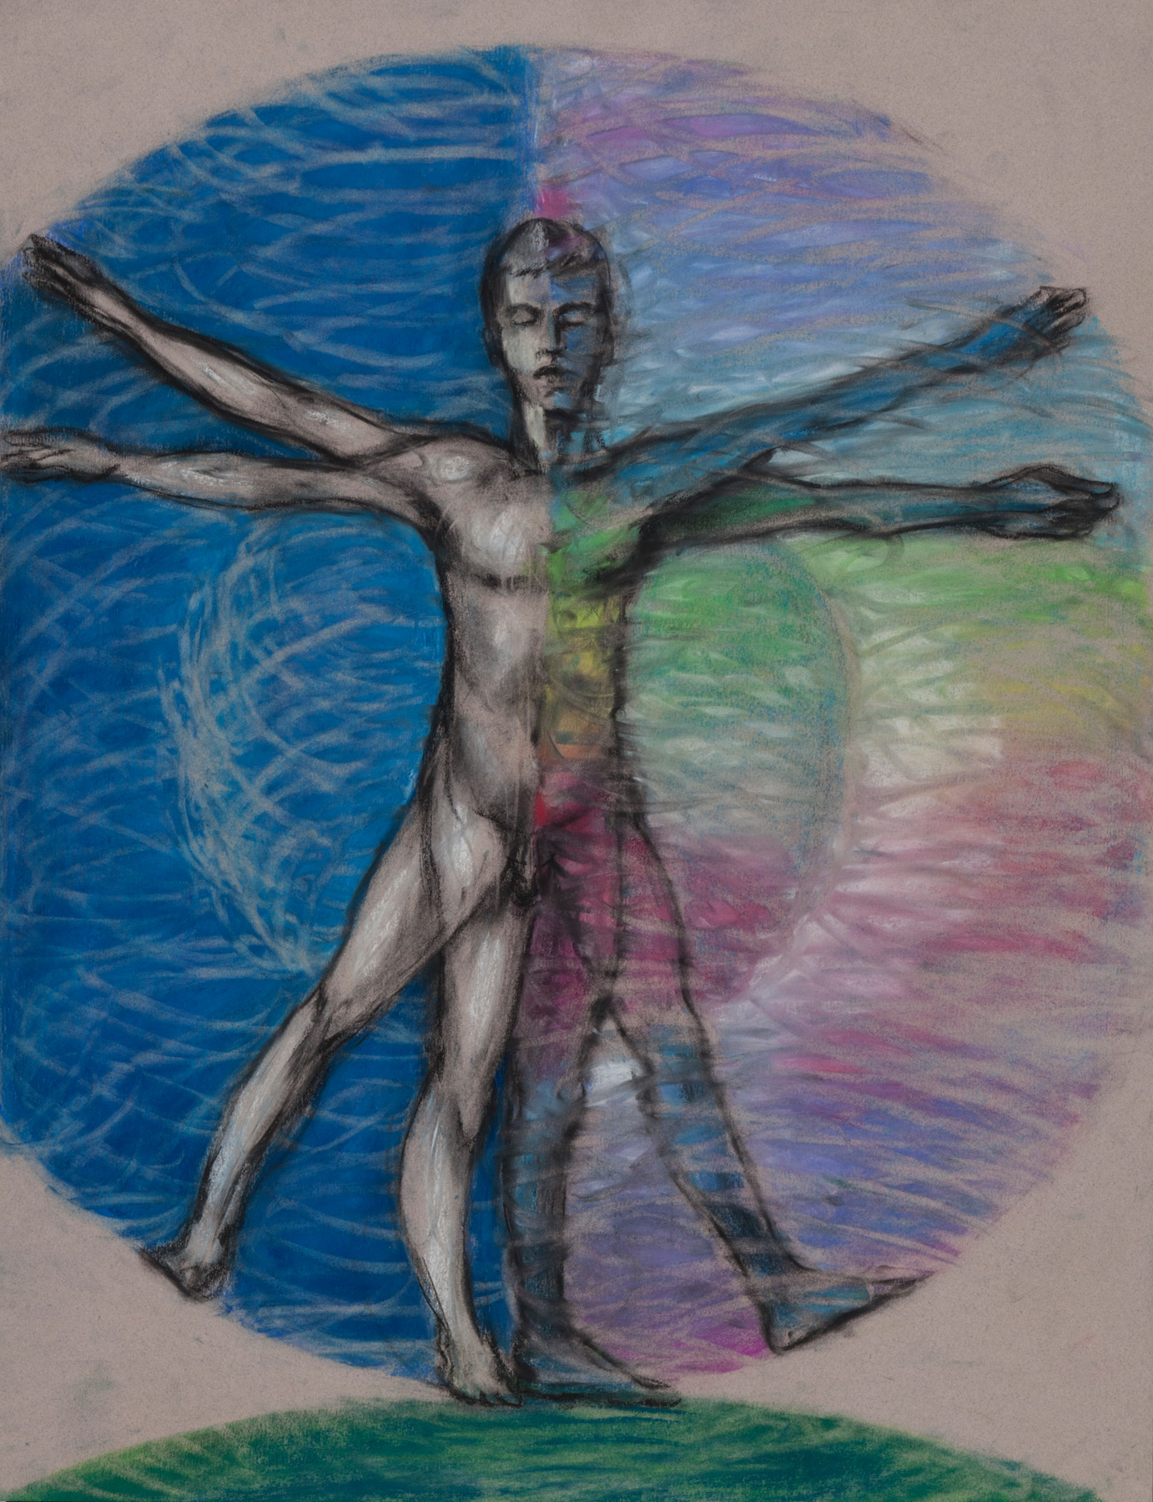 bring conscious intentions into our unconscious past. This would play out in our experience as going after something we only dreamed of doing or being. It would involve taking some risks and going places perhaps you have never been before. An expanded possibility is brought into awareness through presence on the left side. Occurring on the left side is a dimension navigated into only by the left leg and foot. This is a body level experience that expands us into the energy field that surrounds us. Exactly like the right leg and foot, the left leg and foot can tap into the the energy pool of probability on our left side. This expands our possibilities (choice) by allowing us to consider being and going places we may not have even thought possible before because we chose not to. We often do not make choices that may have been in our best interest because of pictures held in our legs, pictures that hold us back usually out of fear.

Our legs and feet have been put through a lot of “support” with canes, walkers, braces, and medications just to be able to walk. The legs and feet are literally our contact to our extended dimensions on our left and right sides. These amazing energy tools go way beyond the ability to walk because they walk us into a reality of possibility as experience.

Both legs take us there, literally, and with consciousness to a dimension of space and time flow below the feet. By grounding through your legs and feet you are visualizing a present moment directly below you with the future to your left and past to your right. You literally are standing on a dimension, I call it Earth, but you can call it whatever you want. A connection to Earth and the dimension we experience through connecting (or not connecting) to it is expanding. This is why you may at times feel connected, but not connected at the same time, because you are using some of your energy that was previously used to just ground with the Earth, to now explore the possible dimensions on your left and right sides. I say possible because these areas contain potential states and are “there” and “real” when paid attention to, by you in your experience.

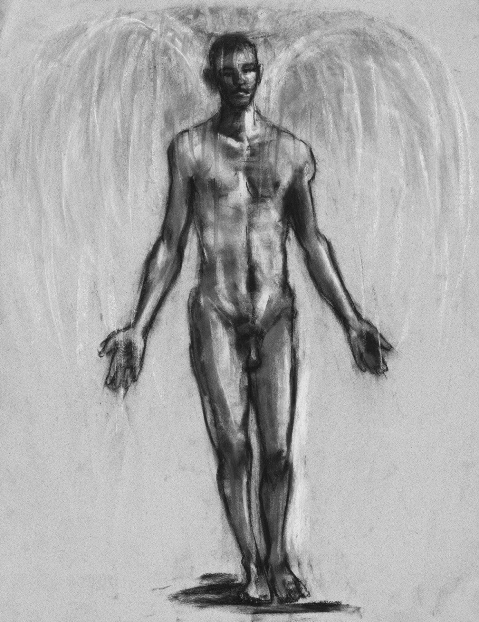

To be present you have to ground and connect into the earth directly below your feet and secure a link to space time below the feet, and check that the time is set in the present. It is easy to ground into the past or the future unknowingly, by doing so, you change your ability to stay present. Being grounded into the past or future causes discomfort for the legs, as well as all other energy systems of the body. Your entire life will be affected by grounding into past time or future time.

Also notice if you are grounded into other “stuff” like people, situations or anything that is outside of your body and outside of present time. Grounding into stuff like money, relationships, careers, real estate, alcohol, drugs, confusion, or fear will halt your momentum as a conscious evolving being. Most people I have found who are grounded in the past receive a big upgrade in the life experience by simply making an effort to connect into the present moment.

Energetically the future, present and past, all happen at the same time, so noticing your body’s relationship to space time is key to having a present time experience. A conscious present left leg is aware of all grounding possibilities, this “yet to be” is the immediate future.
The right leg reveals the actual grounding reality, this “done deal” is the immediate past.

It is with both legs that we are grounded into present time and at the same time extend and expand our presence into the dimensions on our left and right. It is our legs that do the actual exploring of this space-time by allowing you to consider choices you did not make before and perhaps were unaware you had available to you as choices. The expanded space is deeply felt with the legs. I say felt because the legs are filled with pictures of emotions and in a clairvoyant reading it is images of feelings that I very often come upon and read.

More awareness brought into our legs informs us about our expanded energy. Information about security, general health, pleasure, comfort, food, addictions, and money changes as we locate the present moment and expand from there.

The feet can explain a lot about how a person exists on this Earth, and more importantly in the body they have been living in up until this present moment. The feet also hold information about our perceptions of reality. The feet are our physical contact with the ground and each foot chakra indicates an identification of just who you are in this body.

Making our own perceptions is vital to our current conscious evolution. If you do not make your own perceptions someone else will make them for you. Check your legs for perceptual conditions set up by you or someone else in your experience. An exercise that can help evaluate your perceptual equilibrium is to stand in the universal man posture. Arms outstretched and legs at least hip distance apart. From this posture close your eyes and take ten consecutive breaths.
On each inhalation pull energy up from your feet into your body and release it out the top of your head. On each exhalation allow energy to release through the body out your feet. In the feet out the top of the head and in the head and out the feet, a flow of energy in both directions at the same time. As your arms get tired allow them to hang at your sides and relax your shoulders. With each consecutive breath notice the pads of your feet touching the floor, you should feel a slight wobble to your balance. Notice where your attention wants to go. Don't resist the urge to go wherever your mind takes you, thought forms, worries, questions and feelings are all a part of the experience. Breathing naturally, rhythmically consecutive breaths, feeling the flow of energy moving through your body.

You are grounded into a present moment below your feet and there is one above your head. Imagine the present moment above the head, below the feet, in front, in back, to your left and right as one dimensional point. Imagine your physical body in the center as a nucleus within a cloud of present moment electrons. This imaginational exercise combined with a physical exercise becomes an event within your experience. You make it matter by placing your attention on anything,

Your life is walked by the feet and connected to the legs that connect to the rest of the body and energy centers found there in present time and space. Your private reality constructed by your perception, consciousness and unconscious is unique to you.

All other beings on this planet are linked to you as your experience. This experience is momentum and momentum is what you felt in the exercise we did before. The energy momentum you activate by existing in a space time relationship on Earth gives you the life you witness and allows you to perceive it as your own.

We generally exist in a dualistic paradigm that has in its construct an influence perpetuated by money. All money issues and the information about our relationship to money is stored in the legs. Money has energy because we give that characteristic to a piece of paper. We store almost all money as energy images in our legs because money is a construct of experience.
If you want to understand how you define that relationship, and influence your ability to have or not have money, examine the legs and feet. Stored there are the pictures and energy images that will tell you that story and help influence any change or healing. Because the legs and feet are so energetically fixed and fundamental to our obvious journey, money and security are deeply rooted there in the physical manifestation. To heal or make a change in that relationship is often a lifetime process because so much is unconscious.

The entire back of the legs, as well as the back of the torso is constructed of the unconscious and what is stored in that aspect of our being. Often our money concepts are lodged in the unconscious and learned or passed down from the lineage we downloaded from birth.
Making a drastic change in that relationship is attempting to heal a core issue fixed in a contained experience. Sometimes the cards you’re dealt are your launch point to making a change. Honoring the circumstance and making your move from here can completely reframe the core issue into core strength. You cannot create or destroy energy, but you can transform the relationship you have with anything.

Take what you can from the energy level you have set up and rather than trying to change fundamental energy change the momentum. All your emotions, understandings, willingness to have, and ability to connect regarding money are fixed in each leg channel and foot chakra.
Looking at and studying your momentum will gather up what you already have available and, with perception clear, offer you alternatives to structure and free up the pictures long held in unconscious energy patterns. This is where being present is vital, because only there can you truly heal or change.

If you pay attention to your feet and give them direction and attention they will guide you on the best possible energy route available to you and your life journey. It is very similar to a GPS, know your current location and consider your possible destination and let the feet search out your best possible route.

Never underestimate the power of paying attention to location and destination, and always include the feet in this objective for maximum effectiveness. Remember even GPS systems at times fail to provide the optimum route available, so cut yourself some slack and consider alternatives. Don’t be in a hurry to make significant changes to momentum, patience is your virtue, and success with havingness will be your reward. Always know there are many roads that lead to a possible outcome that is in affinity with your journey.

We have successfully covered the major energy centers of the torso, the arms, the legs, and the energy centers above the head and below the feet. This gives us a picture of what we look like as energy. We are energy, and we have presence in the now.

Why we are here now is to attain a sustainable presence. This is the answer to our game of, why here and why now? Consciously being here now and meeting the experience with all of our energetic capability is the joy of conscious evolution.

